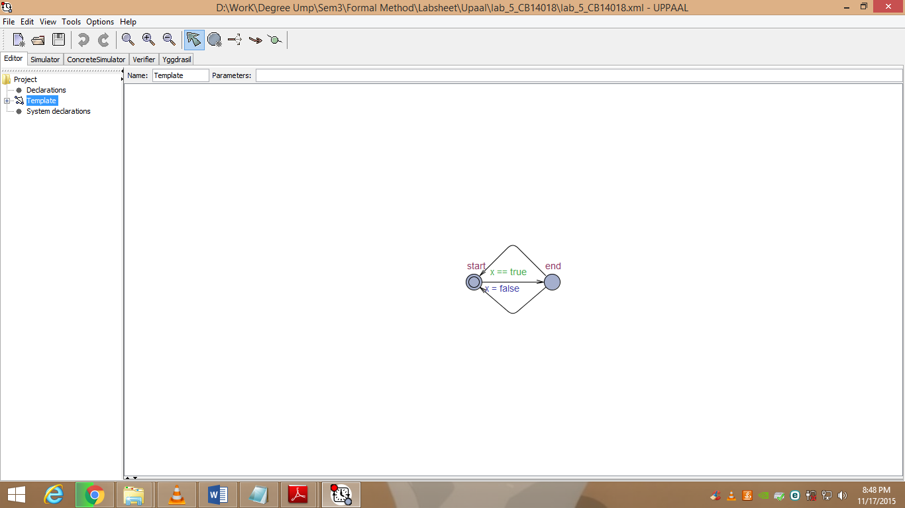

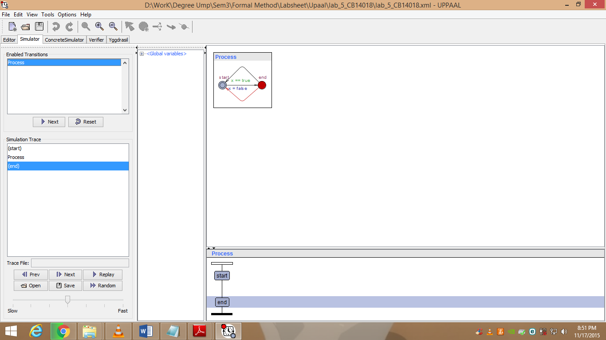

* It will allow the transition from start to end if x=0 is false and from end to start if x=1 is true.

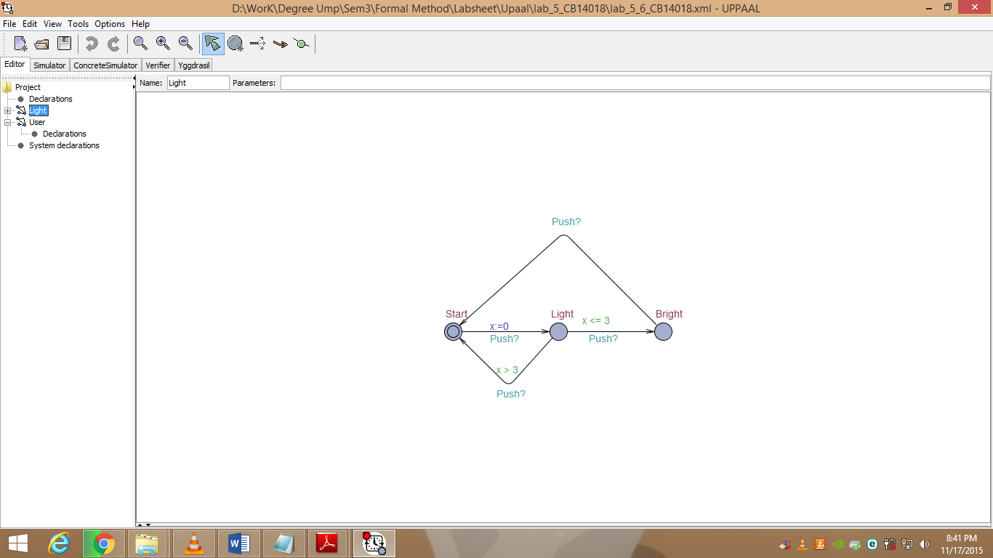

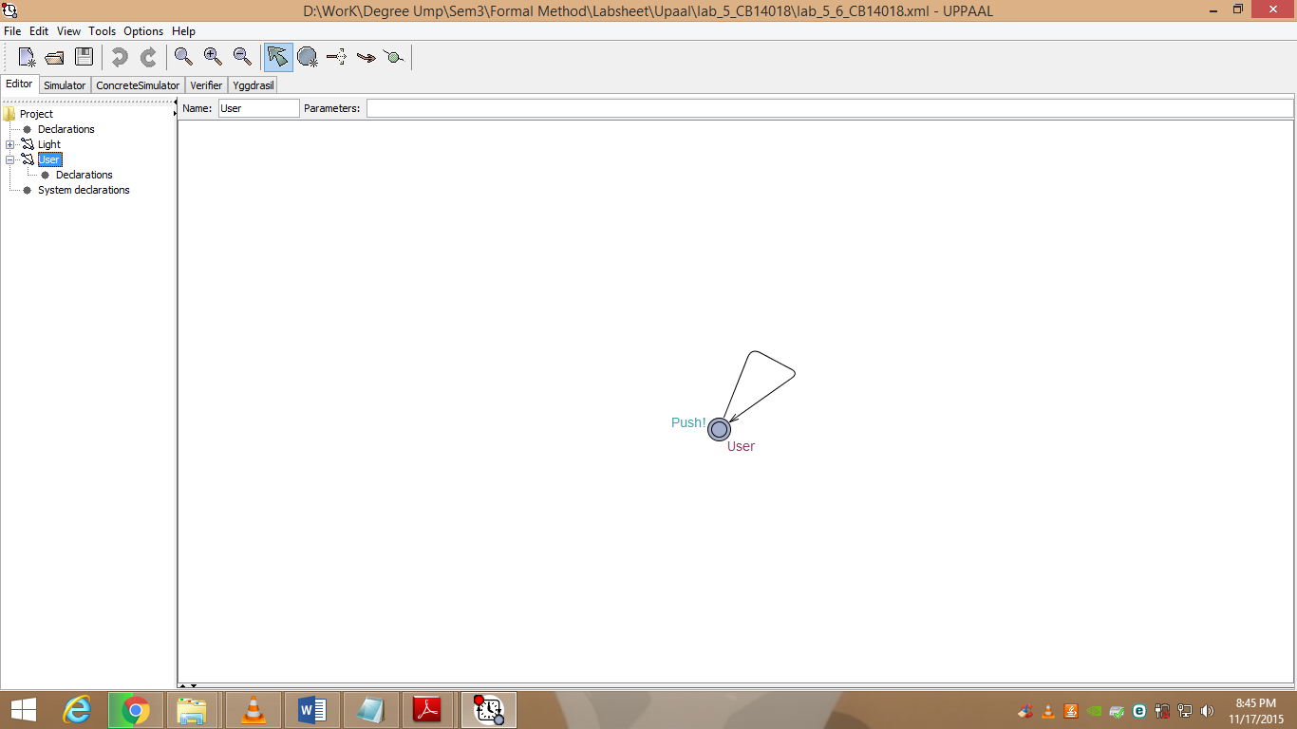

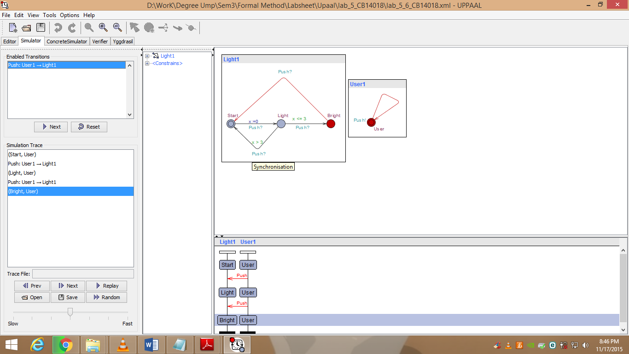

**Question 6.2**

* In editor pages Light and User are templates (types) of processes (automations).
* Then, in simulator pages Light1 and User1 are instances of these templates (processes) so system composed of Light1 and User1 processes.

**Question 6.3**

* When the property of the Light Control system: A [] (x>=0) to be checked the property is satisfied.